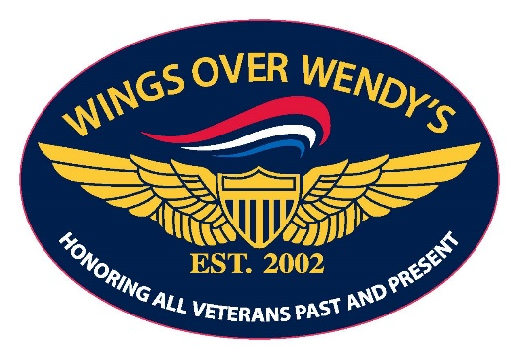 Volume 13 Number 8 Established May 2014 August 1, 2026

WINGS

NEWS
Ed Reynolds Publisher Email Wings News at Ed_ReynoldsJr@msn.com Ed Reynolds Editor

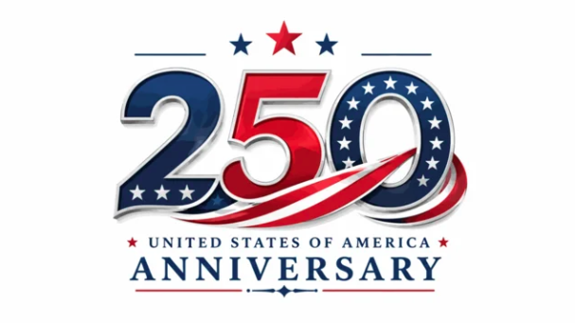

America’s Anniversary
On July 6, 2026, Ed Reynolds returned to the podium after a month of vacation travels. He deviated from the raffle to celebrate America’s 250th Anniversary by passing the microphone to each member and asked them to tell us what they were doing fifty years ago on America’s 200th Anniversary.
We heard many interesting stories and many that don’t recall that it was a special day. Those who were on active duty in the military remembered fireworks celebrations on their bases, but many who had returned to civilian life remembered it as just an ordinary holiday.
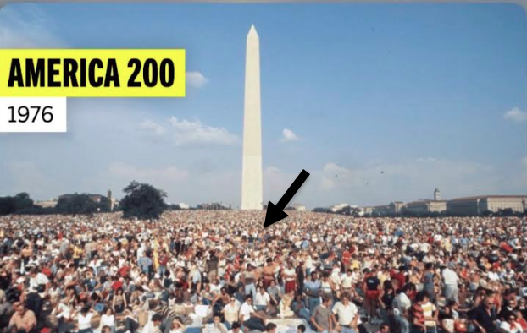
Ed Reynolds then displayed where he and his family spent July 4, 1976. It was the opening of the Smithsonian National Air and Space Museum that weekend, and his family came to Washington, D.C. for the festivities.
They spread their blankets near the Jefferson Pier Stone, on a line between the White House and the Jefferson Memorial, and on a line between the Washington Monument and the Lincoln Memorial.

July 2026 Meetings

July 6, 2026
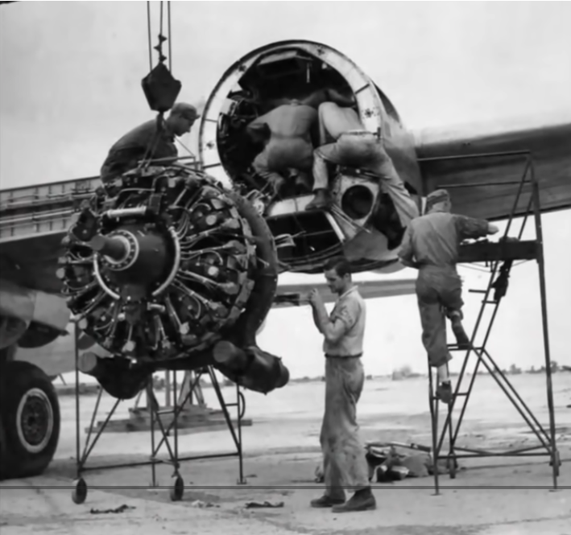
How One Plumber's 'RIDICULOUS' Pipe Idea Saved 5,000 Bomber Engines
The featured presentation on July 6, 2026, was the video titled, “How One Plumber's 'RIDICULOUS' Pipe Idea Saved 5,000 Bomber Engines.”
The video tells the remarkable, little‑known World War II story of how a civilian plumber’s unconventional idea ended up saving thousands of engines on the U.S. Army Air Forces’ B‑29 Superfortress bombers. During WWII, the B‑29 was one of the most advanced aircraft ever built, but its engines—specifically the Wright R‑3350 Duplex Cyclone—were notoriously prone to overheating, catching fire, and failing mid‑flight. These failures threatened missions, cost lives, and jeopardized the massive strategic bombing campaign in the Pacific.
Engineers and military mechanics struggled to solve the overheating problem. The B‑29’s tightly cowled engines trapped heat, and airflow solutions were complex. Traditional fixes—redesigning baffles, adjusting cowl flaps, modifying airflow—were slow, expensive, and often ineffective. The situation grew urgent as more aircraft were lost to engine fires than to enemy action.
Enter an unexpected hero: a plumber working at a modification center. While observing the mechanics’ frustration, he suggested a simple idea inspired by everyday plumbing—installing a curved pipe to redirect airflow more efficiently around the engine. The idea sounded absurd to trained engineers, who initially dismissed it as amateurish. But desperation and curiosity led them to test it.
(Continued page 3)
To everyone’s surprise, the plumber’s pipe dramatically improved cooling. By channeling air more directly to the hottest parts of the engine, temperatures dropped enough to prevent catastrophic failures. The fix was cheap, easy to install, and required no redesign of the aircraft. Once adopted across the fleet, the modification prevented an estimated 5,000 engine losses, allowing the B‑29 to operate safely in the harsh conditions of the Pacific theater.
The video frames this story as a testament to unconventional thinking and the value of practical, hands‑on problem solving. It highlights how innovation often comes from unexpected places—and how a “ridiculous” idea from a non‑engineer helped keep one of WWII’s most important aircraft flying, ultimately contributing to the success of long‑range bombing missions and the end of the war.
July 13, 2026
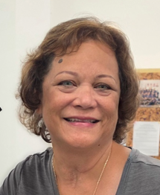
Photo by Judy Lamppu
Lani Kane, Secretary,
Veterans Affiliated Council, Visits WOW
On July 13, 2026, Lani Kane, Secretary of the Veterans Affiliated Council, which serves in Sacramento as a clearinghouse for legislative information, honoring and supporting activities sponsored for veterans and active military personnel, visited the Wings Over Wendy’s meeting.
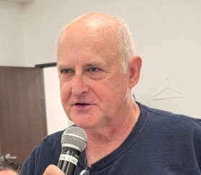
Photo by Judy Lamppu
Jay Tyzzer
Attends Wings Over Wendy’s Meeting
Also on July 13, 2026, Jay Tyzzer, who has attended Wings Over Wendy’s functions in the past, attended his first meeting. We hope to see more of him in the future.
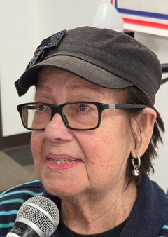
Photo by Judy Lamppu
Margareta Zilliacus Attends WOW Meeting
Another guest at the July 13, 2026, meeting was Margareta Zilliacus, the featured speaker's wife. She has her own stories to tell about WWII. Growing up in the Philippines during the Japanese occupation.

Photo by Judy Lamppu
Dwight Hanson from the You Were Worth IT Foundation Visits Wings Over Wendy’s
On July 13, 2026, Dwight Hanson from the You Were Worth IT Foundation brought the guest speaker and his wife to the meeting. Dwight is active with the You Were Worth IT Foundation, which brought eight WWII Veterans to Normandy on June 6th, 2024. Bill Dillon was on the trip but got sick in France and missed the ceremony.
The YWWIT visits military bases weekly, working with active-duty military to gift diapers and other supplies to young military families; provide pizza, prayer, and encouragement to sailors and Marines; and host BBQs, Back-to-School events, Trunk-or-Treats, Thanksgiving meals, Christmas parties, and more for our service members and their families.
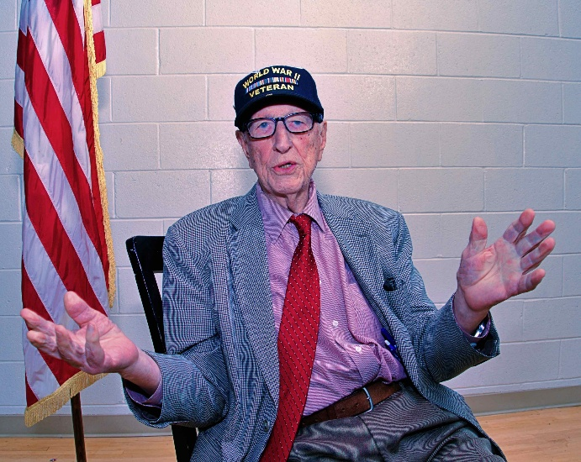
Photo by Larry Kushner
100-year-old WWII Submariner Patrick Zilliacus
(Continued page 4)
The featured speaker on July 13, 2926, was Patrick Zilliacus, a WWII submariner and friend of Bill Dillon’s who had just turned 100. He is an author and artist who illustrates his own books.

His hometown in Finland, painted from memory, is an example of his artwork.
The presentation began with a short CBS LA video of the LA City Council presenting Patrick Ziliakas with a certificate on his 100th birthday.
Bill Dillon then told us he considered Patrick to be his younger brother and provided additional details about Patrick, highlighting his status as one of the last living submarine veterans and the special certificate he received.
Patrick then thanked Bill Dillon for the introduction and shared a humorous anecdote about his preference for In-N-Out Burger over Denny's, without mentioning Wendy’s. He then mentioned his books, which predict the future, and his autobiography, which he wrote without including embarrassing details.
Dwight Hansen highlighted Patrick Ziliakas' autobiography and a book he wrote, "Blockade," which was praised by a Navy admiral. He emphasized that Patrick has written four books since he turned 97 and that he has baseball cards that tell his story. Patrick humorously offered his baseball cards for sale at $20 each.
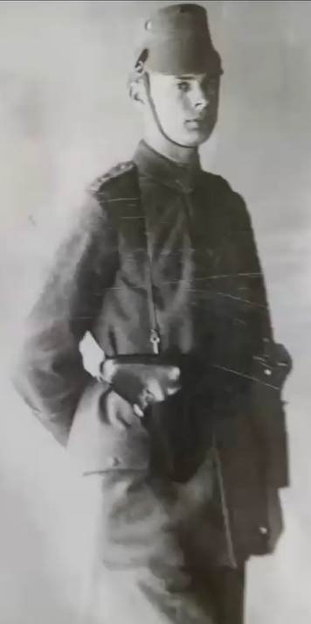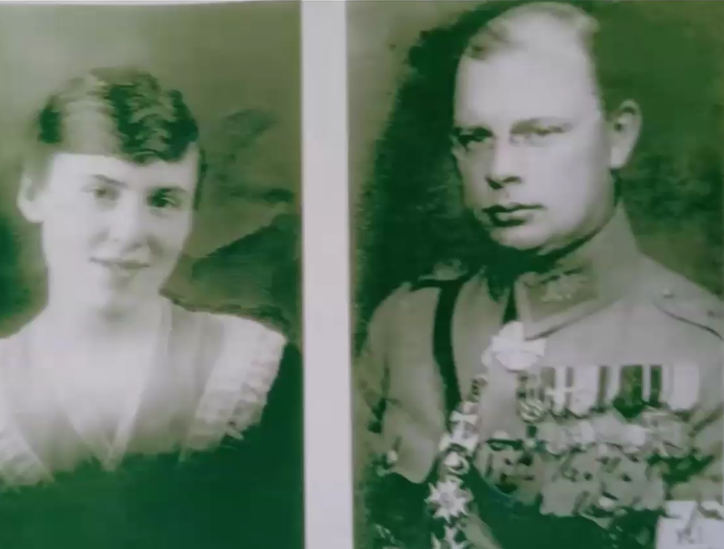
Then Patrick got serious about his Finnish heritage and his involvement in the Finnish National Guard Junior Department before joining the U.S. Navy. He showed us his family pictures. Noting his father's three Iron Crosses
He provided a detailed history of Finland, including its independence from Russia and his family's role in the country's politics and military. He recounted his father's service in the Prussian army during World War I and his subsequent role in the Finnish military. Patrick describes the family's wealth and influence in Finland, including his great-great-grandfather's brick factory and estate.
Patrick discussed the Finnish-Russian War and the German-Russian treaty that divided Poland and other territories. He recounted the British and French plan to send troops to help Finland, as well as the subsequent Russian peace offer. Patrick describes his father's role as the Finnish military attaché in Washington and his interactions with Franklin Roosevelt. He shared his family's journey to the United States, including their temporary visa and their eventual settlement in Chevy Chase, Maryland.

Patrick’s father and his Chevy Chase, MD house.
After the US entered WWII, Patrick’s father left the United States, leaving his family behind. By 1943, Patrick was working in a steel mill and decided to join the US military, finding that the easiest way to enlist was into the US Navy Submarine Service, where he served as a torpedoman. Patrick described the submarine's missions, including sinking ships and engaging in a gunfight with Japanese escorts. He shares a humorous anecdote about depth-charge medicine and the Navy's alcohol policy during World War II. It was outlawed on submarines except if they were attacked by depth charges. On those occasions, small bottles of alcohol were issued to crewmembers to settle their nerves after the attack.
Bill Dillon pointed out to the audience that Patrick was granted a commission in the US Navy and served 18 years in the US Navy Reserve.
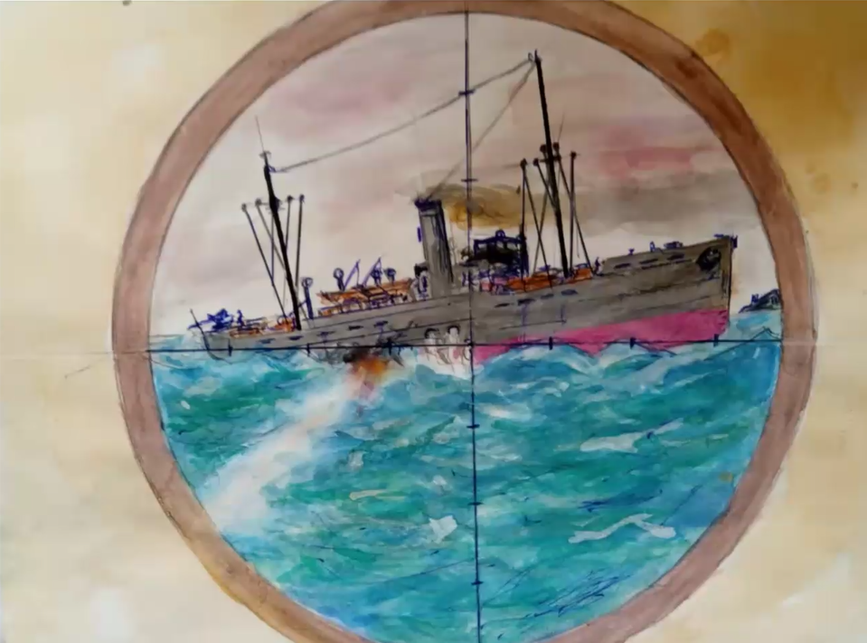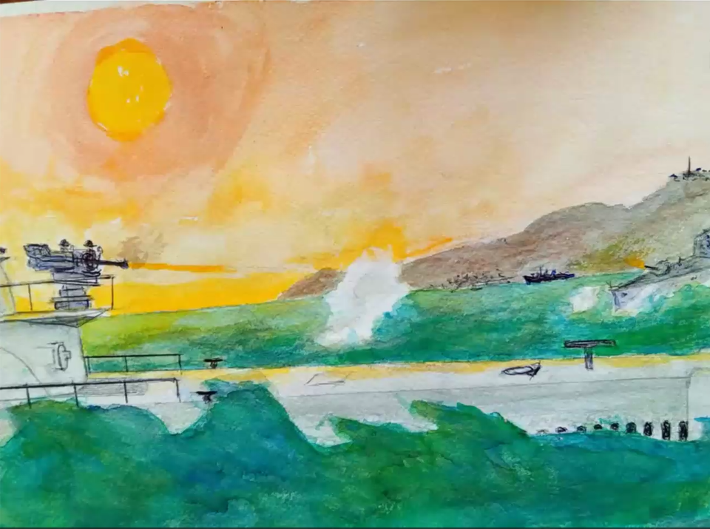
Two of his paintings from memory in his books.
The presentation concluded with a Q&A session in which Patrick discussed his post-war career, including his work as an engineer and CEO of various companies, and expressed his pride in his Finnish heritage and his love for the United States.
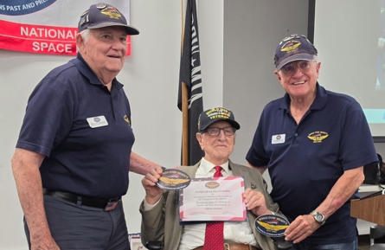
Photo by Judy Lamppu
Bob Eisenhart and Ed Reynolds present a Certificate of Appreciation to Patrick Ziliakas
July 20, 2026
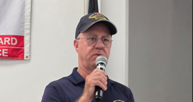
Photo by Judy Lamppu
David Timmerman Promotes Peter Helm’s Celebration of Life
On July 20, 2026, David Timmerman addressed the meeting to share the history of Peter Helm’s acting career, whose Celebration of Life is scheduled for August 1st at the Elks Lodge from 1 to 4 PM.
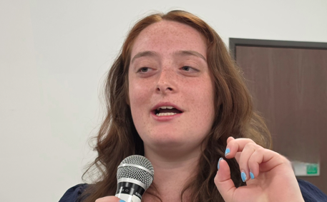
Photo by Judy Lamppu
Solen Ronarch Visits Wings Over Wendy’s
Field Representative for Assemblymember Jesse Gabriel, Solen Ronarch, attended a Wings Over Wendy’s meeting on July 20, 2026.
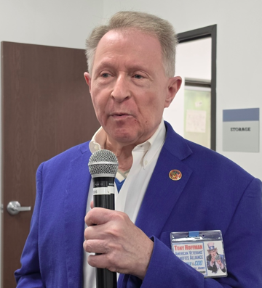
Photo by Judy Lamppu
Tony Hoffman, American Veterans’ Benefits Alliance, Inc. Visits Meeting
On July 20, 2026, Tony Hoffman, Founder and COO of American Veterans’ Benefits Alliance, Inc., visited Wings Over Wendy’s to inform the group about his organization’s ability to assist veterans in optaining long tern care benefits.
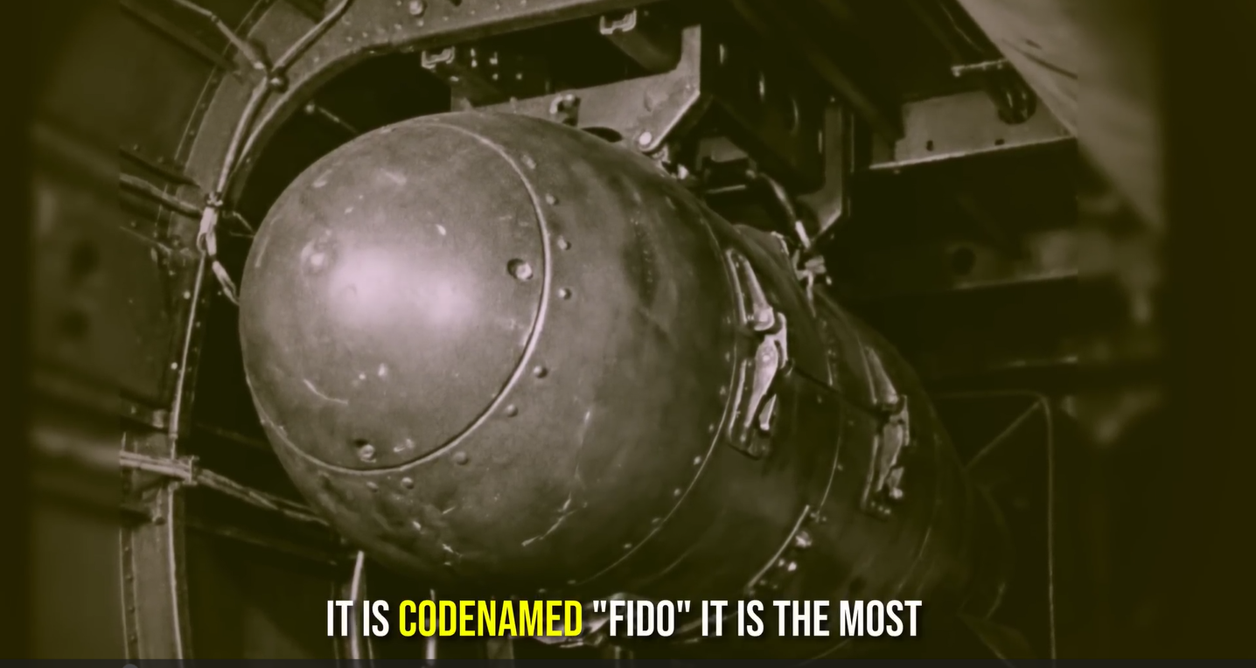
(Continued page 6)
They Called It a ‘Mine’ to Hide Its Secret – It Sank 37 U Boats Without Missing
The featured video on July 20, 2026, was titled: They Called It a ‘Mine’ to Hide Its Secret – It Sank 37 U Boats Without Missing. The video explores one of the most unusual and effective anti‑submarine weapons of World War II: the Mark 24 “Fido” acoustic homing torpedo, a device deliberately disguised as an aerial “mine” to conceal its true purpose. Developed by the U.S. Navy and the National Defense Research Committee, Fido was the world’s first successful air‑deployed homing torpedo and became a decisive tool in the Battle of the Atlantic.
The narrative begins on May 12, 1943, when an RAF Liberator spotted a German U‑boat in the North Atlantic. Instead of dropping traditional depth charges—which required guessing the submarine’s position after it dove—the aircraft deployed a Fido. Unlike conventional weapons, Fido actively listened for the submarine’s propeller noise and steered itself toward the target. This technological leap dramatically increased the Allies’ ability to destroy U‑boats that previously escaped by crash‑diving.
The video explains how the weapon worked: once dropped, Fido entered the water quietly, activated its acoustic sensors, and homed in on the submarine’s engine noise. Its slow speed was intentional—quiet enough not to alert the U‑boat and precise enough to maintain lock. Because of its reliability, Fido achieved an extraordinary record: 37 confirmed U‑boat sinkings without a single miss, plus dozens more damaged or forced to surface.
To maintain secrecy, the Allies publicly referred to Fido as a “mine”, preventing Germany from understanding how their submarines were being hunted so effectively. The Germans never developed a countermeasure during the war, largely because they didn’t realize what was happening.
The video places Fido’s impact in strategic context: by 1943, U‑boats were threatening Allied supply lines, and the introduction of Fido helped turn the tide. Its success contributed significantly to reducing U‑boat effectiveness, protecting convoys, and securing the Atlantic for the remainder of the war.
The story highlights the collaboration between scientists, engineers, and military personnel, showing how rapid innovation—combined with secrecy—produced one of the most effective and least‑known weapons of WWII. The Mark 24 “mine” stands as a milestone in guided‑weapon technology and a quiet hero of the Atlantic campaign.
July 27, 2026
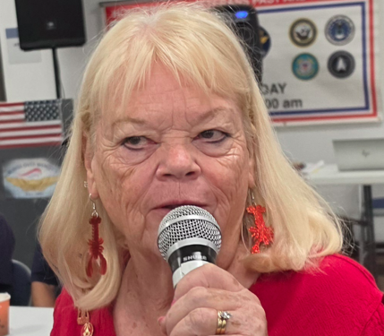
Photo by Judy Lamppu
Jo Lamoreaux Visits Meeting in Person
Jo Lamoreaux, who usually attends meetings via Zoom, attended the July 27, 2026 meeting to take reservations for the Elks Lodge Annual Lobster Fest, scheduled for August 22, 2026.
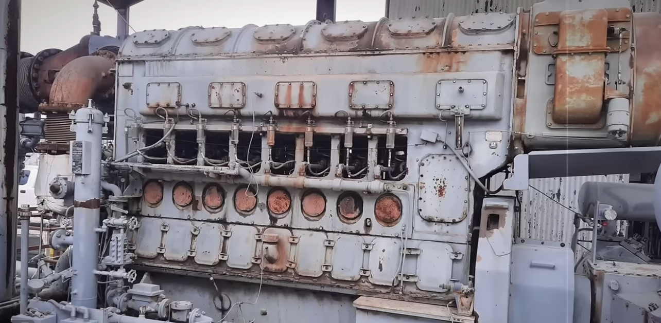
Engineers Ridiculed This Motor — Then It Decided The Pacific War!
The featured video on July 27, 2026 was titled: Engineers Ridiculed This Motor — Then It Decided The Pacific War
(Continued page 7)!
The video tells the unlikely story of a diesel engine that began its life as a ridiculed passenger‑train motor in 1933 and ultimately became one of the most decisive technologies in the Pacific War. Initially dismissed by engineers as a “toy,” the Fairbanks‑Morse opposed‑piston diesel engine was designed for the Pioneer Zephyr, a lightweight American passenger train. Its unconventional architecture — including the absence of a traditional cylinder head — made it seem impractical and even laughable to many experts. Yet its simplicity, reliability, and efficiency would later prove revolutionary.
The U.S. Navy, seeking dependable powerplants for its submarine fleet, took a gamble on this unusual engine. Fairbanks‑Morse, a company better known for industrial weighing scales, out‑engineered European competitors and delivered a motor that could run smoothly under extreme conditions. Despite skepticism, the Navy installed these engines in a portion of its submarine force — a small 1.6% of the fleet that would go on to sink half of all Japanese ships lost at sea during World War II.
The video highlights one dramatic example: January 23, 1945, in Namkwan Harbor, China, where the submarine USS Barb penetrated a Japanese anchorage in dangerously shallow water. Unable to dive, Barb fired all her torpedoes and then made a desperate 79‑minute surface escape at 21 knots, threading through minefields. Her survival depended entirely on the reliability and sustained power of her four Fairbanks‑Morse engines — the same engines once mocked as unsuitable for serious work.
The documentary frames this as a “forensic audit” of how an underestimated piece of engineering became a wartime asset. It explores why the Navy chose a passenger‑train engine, how Fairbanks‑Morse achieved its breakthrough design, why German diesel engines earned an unprintable nickname among sailors, and how Japanese naval officers were tasked with defending an empire increasingly vulnerable to American submarine attacks.
Ultimately, the video argues that this ridiculed motor played a pivotal role in shifting the balance of power in the Pacific. What began as an engineering curiosity became a strategic advantage — a reminder that innovation often comes from unexpected places, and that the machines shaping history are not always the ones that look impressive on paper.

Wings Over Wendy's Future Events:

Peter Helm
Celebration of Life
AUGUST 1st
Elks Lodge 1 to 4 pm

2026 Wings Over Camarillo Air Show
August 15-16, 2026

2026 Awards Luncheon
September 24, 2026
Woodland Hills Country Club

2026 SFV Veterans Day Parade
November 11, 2026

Wings Over Wendy's Partner Club Events:

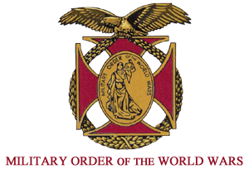
MOAA/MOWW DINNER MEETING
NO AUGUST MEETING

CANOGA – OWENSMOUTH HISTORICAL SOCIETY
NO AUGUST MEETING
(
Big Band AUGUST 15th


In Memoriam
No deaths of members were reported during the month.

Prayers
Duane Buckley, Marilyn Hauck, Connie Hein and Gloria Derge are at home or in convalescent care facilities.

August Birthdays
Bob Donovan August 1 1948
Marcel Ferland August 2 1948
Robert Lee August 2 1944
Nathan Spiewak August 3 1933
Ray Perkins August 4 1944
Morton Shechtman August 4 1945
Ed Reynolds August 5 1935
Nina Hoffmann August 6 1967
Joe Trotta August 8 1936
Chuck Winburn August 8 1947
Stuart Weinstein August 16 1957
Penny Korechoff August 20 1943
Richard Hernandez August 21 1953
John Pemberton August 21 1935
Bruce Greenwood August 26 1943

Wings News Patrons
The following is a list of WOW members who have contributed $10 to fund the publication for 12 months.
David Alvarez Lee Ambers
Shirley Ambers Dave Anderson
Lillian Anderson Shirley Andrews
Lee Auger Mark Ax
Peggy Jean Bassett Tom Bates
Ron Boggess John Boiko
Robert Bremer Richard Burns
Marge Callahan Michael Castro
Barry Chapman John Cromwell
Duc Dao Gloria Derge
Gerald Detamore William Dillon
Bob Donovan Ricard Dunner
Steve Dunner Jan Edwards
Bob Eisenhart Nancy Eisenhart
Ellie Harrison Mike Emch
Nancy Emch Gordon Fell
Sharon Fine Darryl Fisher
David Freeman Bill Garland
Glenn Gates David Greenberg
Carter Greene Bruce Greenwood
Joseph Guevara Ellie Harrison
Marilyn Hauck Peter Helm
Richard Hernandez Corinne Ho
Abe Hoffman Carol Jensen
Julio Jimenez Fred Kaplan
Steve Klausner Jerry Knotts
Andy Kopetzky Victor Korechoff
Larry Kushner Erick Lace
Jill Lace Howard Lewis
Vivian Lewis Martin Light
Morris Litwack Frank Lopez
Marion Lovelace Don Maclay
Chuck Mathews Richard McGrath
Christine McIntosh Sheldon Ochiti
Dan Pemberton Maurice Portnoy
Anne Marie Radel Bill Ratner
Ed Reynolds Maria Rodriguez
Ray Rodriguez Andy Romanisky
Sam Rosenfeld Earl Roth
Stanley Salmore Bruce Schultz
Randy Silverman Jim Sivazlian
Jim Sommer Oscar Stein
Dave Steinbacher Chip Stevens
Bob Stiles Jim Swavely
Howard Swerdlick David Timmerman
David Tostenson Maurice Vasquez
Karen Vegtel Karen Velarde
Timothy Velarde Robert Wagstaff
Mark Weber Bruce Wiener
Rochelle Wiener Charles Winburn
Dave Worley

Wings & Meeting Staff
Publisher: Ed Reynolds
Editor: Ed Reynolds (&Grammarly)
Photographers: Larry Kushner, Dave Anderson, Judy Lamppu, Andy Kopetzky, Michael Sugar
Audio & Video: Max Carlisle
Meeting Secretaries: Marion Lovelace, Shirley Andrews
Programs & Speakers: Bob Eisenhart

Tours: Dave Anderson, Jim Sommers

Events: Gloria Derge

Treasurer: Gordon Fell

Hats & Shirts: David Alvarez, Bruce Schultz

Name Tags: Ed Reynolds

Raffle Tickets: David Greenberg, Lee Ambers

Raffle: Fred Kaplan, Ed Reynolds

Decorations: Fred Kaplan, Bill Ratner

Technical Assistance: Max Carlisle
Coffee & Donut Crew: Barry Chapman, Mark Ax, Karen & Tim Velarde

Room Setup Crew: David Greenberg, David Tostenson, John Boiko, Bill Ratner, Dave Steinbacher

Board of Directors

501 (c) (7), Social Club

President: Ed Reynolds

Vice President: Bill Ratner

Treasurer: Gordon Fell

Secretary: Nancy Eisenhart

Member: Dave Anderson

Member: Bob Eisenhart

Member: Bruce Schultz

Reminder
Wings Over Wendy’s monthly food drive is on Monday, August 3rd



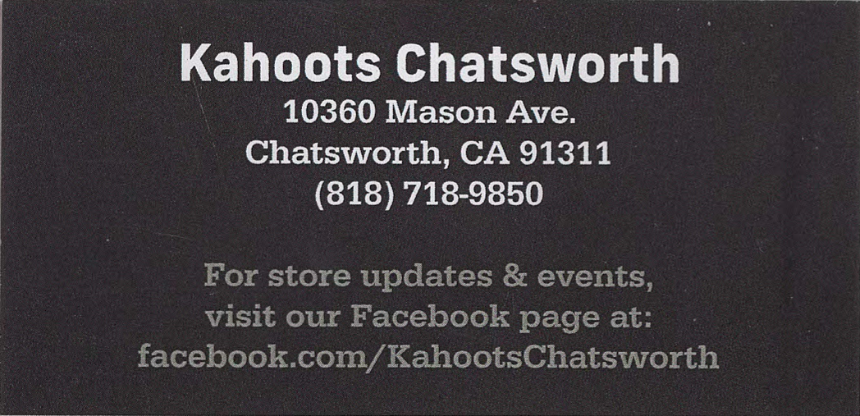
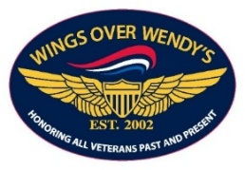
Wings Over Wendy's
Clothing
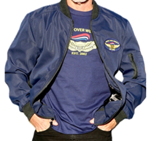
Hats & Polo shirts Jackets

T-Shirt
(For casual wear, not for meetings)
Order from David Alvarez
818-389-2035
dfsadraw@aol.com
or Bruce Schultz
818 489-4021
bschultz49@gmail.com
Order Name Tags from
Ed Reynolds 818-421-8946
ed_reynoldsjr@msn.com

